Prototype Attribute of Objects Created with **new Object () or Object Literal {}**

* Inherits from *Object.prototype*
* Object.prototype itself does NOT INHERIT any methods or properties from any other object
  + Basically siya si God
  + The creator of all objects

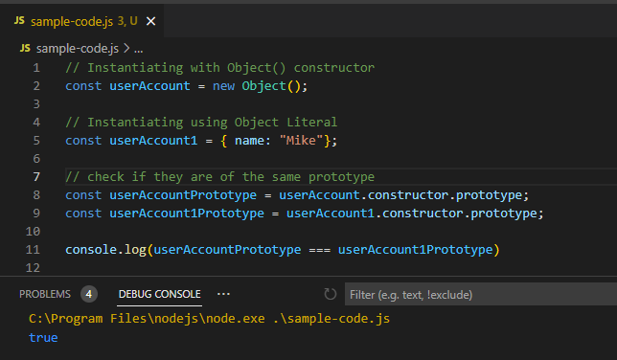

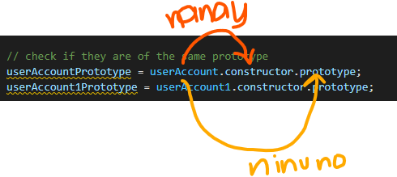

Prototype Attribute of Objects Created With a Constructor Function

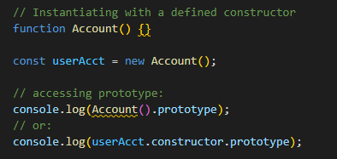

Summary

1. Object created with an object literal
   * Inherits properties from Object.prototype
   * Prototype object/attribute is Object.prototype
2. Object created from a constructor function
   * Constructor.prototype
   * Eg. var fruit = new Fruit() ----> Fruit.prototype